THE UNIVERSITY OF MICHIGAN-DEARBORN

INDUSTRIAL & MANUFACTURING SYSTEMS

ENGINEERING DEPARTMENT

**STUDENT NAME: Demetrius Johnson**

**DATE: 5 April 2021**

IMSE/CIS 381 INDUSTRIAL ROBOTS

Assignment #5

(15 points)

1. A three-machine workcell uses one single robot to load and unload the machines. The robot picks up a part from incoming conveyor and loads it on a machine fixture, then after completion of machining it unloads the part and drops it onto exit conveyor. The machines have identical cycles. The work cycle consists of the following sequence of activities:

|  |  |  |
| --- | --- | --- |
| Seq. | Activity | Time |
|  | Robot reaches and picks part from incoming conveyor and loads into fixture on machine tool. | 5.5 sec. |
|  | Machining cycle (automatic) | 33.0 sec. |
|  | Robot reaches in, retrieves part from machine tool, and deposits it onto outgoing conveyor. | 4.8 sec. |
|  | Move back to pickup position | 1.7 sec. |

a. What type of workcell layout is the most suitable for this case? Make a sketch of the workcell showing relative positions of different pieces of equipment in the cell.

* The most suitable robot cell layout is the **Centered Cell** since each machine does the same task picking up what I assume to be reasonably sized parts that go into relatively non-large machines, and there are two conveyors (an input and output).

**Machine 2**

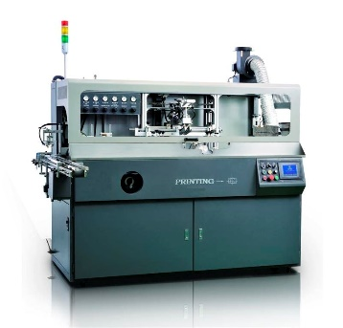

**Machine 1**

**Machine 3**

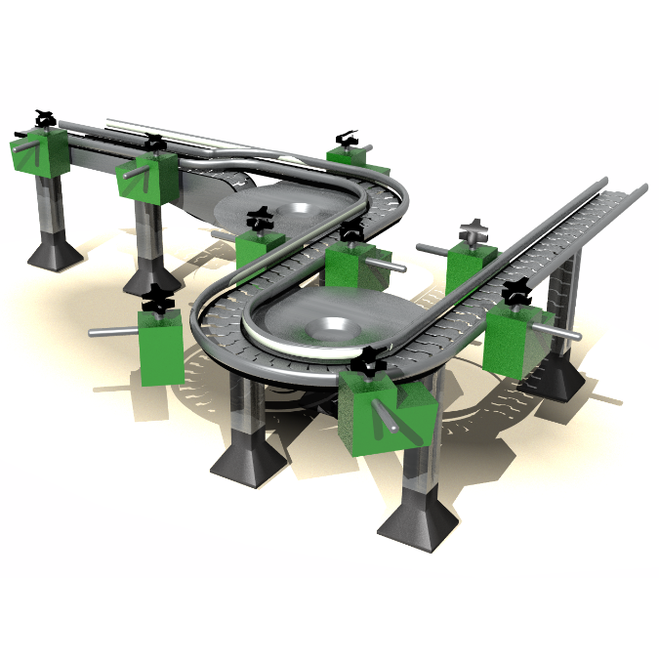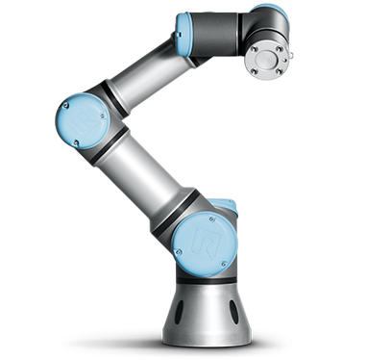

**Robot**

**Output Conveyor**

**Centered Robot Work Cell**

**Input Conveyor**

b. Draw a machine/process time chart showing the activities in the work cell. Indicate on each activity the status of both the robot and the machine.

**SEE EXCEL FILE THAT I UPLOADED WITH THIS DOCUMENT IN CANVAS.**

c. Determine the amount of machine interference and the amount of robot idle time.

* Using my time chart that I created for reference:
  + Robot Idle Time: 9s
  + Machine Idle Time: 0s
  + Service time: 1.7s + 5.5s + 4.8s = 12s
  + Machine Cycle Time: service time + runtime = 12s + 33s = 45s
  + Robot Cycle Time: #machines * service time = 3 * 12s = 36s
    - Also I notice how Robot Cycle Time is 3 seconds more than Machine Cycle Time; thus 3 * 3s = 9s, which will also give me the solution to Robot Idle Time.
  + If the robot cycle time < the machine cycle time, then there will be no machine interference, but the robot will be idle for part of the cycle.
  + **36s < 45s; thus, there is no machine interference in this work cell; there is however a 9s idle from the robot every cycle.**

d. Make a list of the interlocks required for the workcell. For each interlock indicate whether it is an input interlock or an output interlock. For each of the input interlocks, define what the interlock should sense before the signal is sent to the work cell controller. For each output interlock, define what conditions must be satisfied before the signal is sent from the workcell controller.

|  |  |  |  |
| --- | --- | --- | --- |
|  | Interlock (for cell cont.) | Type | Condition |
| 1 | Signal (cell contr🡪robot contr) | Output | order robot to retrieve part from machine and place it on outgoing conveyor if machine cycle is completed **and** output conveyor is clear |
| 2 | Machine Cycle Timer limit switch | Input | machine cycle timer at 0 seconds (completed) |
| 3 | Signal(cell contr🡪output conveyor) | Output | Order output conveyor to exit the part if outgoing proximity sensor detects a part; output conveyor is now clear for reception of a new outgoing part |
| 4 | Proximity sensor limit switch (outgoing conveyor)🡪 cell contr | Input | This will detect and inform cell controller if a part is present on the outgoing conveyor and needs to be exited |
| 5 | Signal (cell contr🡪robot contr) | Output | order robot to acquire a new part from incoming conveyor and place it in a machine if incoming conveyor is loaded **and** machine is clear |
| 6 | Signal(cell contr🡪input conveyor) | Output | Order input conveyor to send a new part if incoming proximity sensor does not detect a part; input conveyor is now loaded with an unmachined part |
| 7 | Proximity sensor limit switch (incoming conveyor)🡪 cell contr | Input | This will detect and inform cell controller if a part is **not** present on the incoming conveyor and needs to move up (load) a new part |
| 8 | Microswitch | Input | Tells if a machine is clear (no part is loaded into the machine) |

e. List five errors which could happen during the operation of this work cell. Give a recovery strategy for each error.

|  |  |
| --- | --- |
| Error | Recovery |
| Robot drops a part | Proceed as normal if conveyors and robot are unchanged |
| Robot arm malfunction | Stop; call operator |
| Limit switch fails | Stop; call operator |
| Machine failure | Call operator; proceed using other machines |
| Machine malfunction | Call operator; proceed using other machines |

(10 points)

1. In the previous problem, suppose that a double gripper is used instead of a single gripper as indicated in that problem. The activities in the cycle would be changed as follows:

|  |  |  |
| --- | --- | --- |
| Seq. | Activity | Time |
|  | Robot reaches and picks raw part from incoming conveyor in one gripper and awaits completion of machining cycle. This activity is performed simultaneously with machining cycle. | 3.3 sec. |
|  | At completion of previous machining cycle, robot reaches in, retrieves finished part from machine, loads raw part into fixture, and moves a safe distance from machine. | 5.0 sec. |
|  | Machining cycle (automatic). | 33.0 sec. |
|  | Robot moves to outgoing conveyor and deposits part. This activity is performed simultaneously with machining cycle. | 3.0 sec. |
|  | Robot moves back to pickup position. This activity is performed simultaneously with machining cycle. | 1.7 sec. |

Steps 1, 4, and 5 are performed simultaneously with the automatic machining cycle. Steps 2 and 3 must be performed sequentially. The same tool change statistics and uptime efficiencies are applicable.

a. Draw a machine/process time chart showing the activities in the work cell. Indicate on each activity the status of both the robot and the machine.

b. Determine the amount of machine interference and the amount of robot idle time.

c. Compare the results of both cases, what would be the effect of the changes on the cell throughput..

(10 points)

3. An industrial robot whose element times are determined by Table 11-2 is being applied to perform a certain pick-and-place operation which requires that parts be picked from a fixed location on a moving conveyor and dropped into a parts magazine at a fixed location. **Each magazine holds 12 parts**. The parts are stacked on top of each other in the magazine so the robot must deliver each part that goes into the magazine to a fixed location. The robot uses an **"approach" and "depart" command for each pickup which is 2 in**. **away from the conveyor surface**. The **parts weigh 1.5 lb each**. The distance between the pickup (**assume 2 in.** above the pickup point) and the magazine loading point is **14 in.** After the 12 parts are loaded into the magazine, an automatic transfer element is activated to replace the full magazine with an empty one**. The element takes 10 s**. A constant speed setting V is to be used for the robot throughout its work cycle. Determine an equation with speed V as an independent variable that can be used to compute the total cycle time for this operation. Assume S > V/2.5.

14 in.

2 in.

2 in.

Input conveyor

Loading Magazine

* 14in. = (7/6)ft
* 2in. = (1/6)ft
* If S > V/2.5, then for element time we use:
  + S/V + 0.40 for R1 (unloaded manipulator along 14in.)
  + S/V + 0.40 for R2 (unloaded manipulator along 2in.)
  + S/V +0.60 for M1 (manipulator with load between 1 and 5 pounds along 14in.)
  + S/V +0.60 for M2 (manipulator with load between 1 and 5 pounds along 2in.)
* 1) Robot replaces full magazine with an empty one; TIME: 10s\
* MULTIPLY THE TIME FROM STEPS 2 – 8 BY 12, FOR 12 PARTS:
* 2) Robot moves to input conveyor approach point; R1 🡪 TIME: [(7/6)ft / V] + 0.40s
* 3) Robot moves to pick up part; R2 🡪 TIME: [(1/6)ft / V] + 0.40s
* 4) Robot closes gripper; GR1 🡪 TIME: 0.1s
* 5) Robot departs; M2 🡪 TIME: [(1/6)ft / V] + 0.60s
* 6) Robot moves to loading magazine approach point; M1 🡪 TIME: [(7/6)ft / V] + 0.60s
* 7) Robot moves to pick up part; M2 🡪 TIME: [(1/6)ft / V] + 0.60s
* 8) Robot opens gripper; RE 🡪 TIME: 0.1s
* 9) Robot departs R2 🡪 TIME: [(1/6)ft / V] + 0.40s

Now solve for an equation for TOTAL CYCLE TIME in terms of V:

* TOTAL CYCLE TIME = 2*([(1/6)ft / V] + 0.40s + [(1/6)ft / V] + 0.60s) + 2*0.1s + [(7/6)ft / V] + 0.40s + [(7/6)ft / V] + 0.60s
* TOTAL CYCLE TIME = 2*((2/6)ft/V + 1s)) + 0.2s + (14/6)ft/V + 1s
* TOTAL CYCLE TIME = (4/6)ft/V + 2s + 0.2s + (14/6)ft/V + 1s
* **TOTAL CYCLE TIME in terms of V= (18/6)ft/V + 3.2s {final solution}**